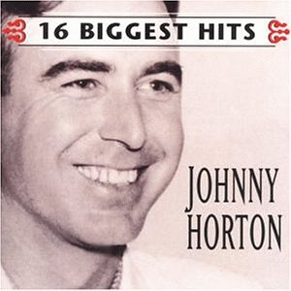

The Battle of New Orleans
#9
Johnny Horton

From the album ’16 Biggest Hits’

Sony Music

Vocabulary

- briars and brambles –
- muskets –
- nigh –

Do You Know It?

Can you find the following places?

- Gulf of Mexico
- Massachusetts
- Mississippi River
- New Orleans
- St. Lawrence Rive
- Washington, D.C.

Do you know these chaps?

- James Madison
- Colonel Andrew Jackson
- General Brock
- Tecumseh
- Laura Secord
- Colonel Fitzgibbon

Did You Catch It?

- Who led the troops down the Mississippi?

- What two groups were fighting?

- What kinds of weapons were used in the battle?

- Why did the Americans wait so long to attack?

- Estimate the number of men involved in the battle:

46

Do You Get It?

- How would you describe the music to this song? (How does it make you feel?)

- Why do you think the songwriter chose this music to accompany the lyrics?

- Is it appropriate to base national pride on events of violence? Why or why not?

Activities and Extensions!

- Compare this song and “The War of 1812 (Three Dead Trolls in a Baggie). Think feelings, content etc. Which one do you prefer? Why?

- Illustrate the battle in a cartoon format.

- Write another verse that describes what happened once the troops reached the Gulf of Mexico.

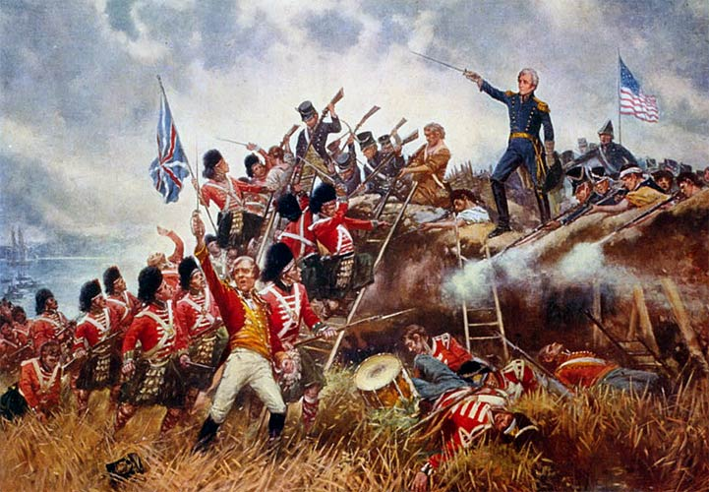
To the right is a famous painting about The Battle of New Orleans.

Which side are the British on?

Who do you think appears strong and victorious?

Whose perspective is being represented in the picture?

Who do you think the man at the top of the painting is?



Teacher’s Guide

BACKGROUND: The War of 1812

Who’s Who?:
James Madison- President of the United States- 1812
Colonel Andrew Jackson- Known as Ol’ Hickory. Arrived in New Orleans in 1814.
General Brock: British General
Tecumseh: Native Chief of the Shawnee Nation
Laura Secord: American born farmer’s wife who lived in Upper Canada (1775-1868)
Colonel Fitzgibbon: British commander

Vocabulary:
briars and brambles: thorny or prickly bushes
muskets: a type of long-barreled gun used by soldiers before rifles were invented
nigh: near or close-at-hand

Expressions:
There wasn’t nigh as many….There wasn’t near as many
We stood by our cotton bales….We stood by barricades that were made of bales of cotton

Did You Catch It?
- Colonel Jackson (“Old Hickory”) led the troops down the Mississippi?
- Americans and the British were the two groups fighting?
- Guns, muskets, squirrel guns, canons were the weapons were used in the battle?
- They wanted to take the British by surprise, so they waited until they got close before firing.
- Estimate the number of men involved in the battle: “There must have been a hundred of them beating on the drum”

Do You Get It?
- The music in this song is up beat, lively, much like a marching tune. It makes you feel energized and patriotic.
- The songwriter’s choice in music emulates the battlefield music of the era (the 1800’s)
- Answers will vary.

On 18 June 1812, at the height of the Napoleonic conflict the US declared war on Great Britain and struck at the only British possession on the continent: Canada. Most of the battles that followed took place along the international border. The war ended in stalemate. The Treaty of GHENT, signed 24 Dec 1814, solved nothing, since the reasons for the war - British high-handedness on the high seas, including searching American ships during the Napoleonic blockade - had been rendered academic by France's defeat. Yet Canada owes its present shape to negotiations that grew out of the peace, while the war itself - or the myths created by the war - gave Canadians their first sense of community.

